**Media Evaluation Manual**

**Table of Contents**

|  |  |
| --- | --- |
| **Topic** | **Page** |
| Login Screen | 2 |
| Sign-up Screen | 3 |
| Media Evaluation (Function) | 4 |
| Adding Books | 4 |
| Switching Tables | 5 |
| Exporting Files | 6 |
| Quick Reports | 6 |

**Login Screen** (Figure 1):

* Specify username and password to log in.
* If user doesn’t have account, sign up.
* For quick testing, click on **Quick Test** to automatically generate credentials and log in.
* If program is running for the first time an input dialog (Figure 2) will pop up and ask for database credential in order the gain access to the database. This will pop up on the sign-up screen as well for first time runners.

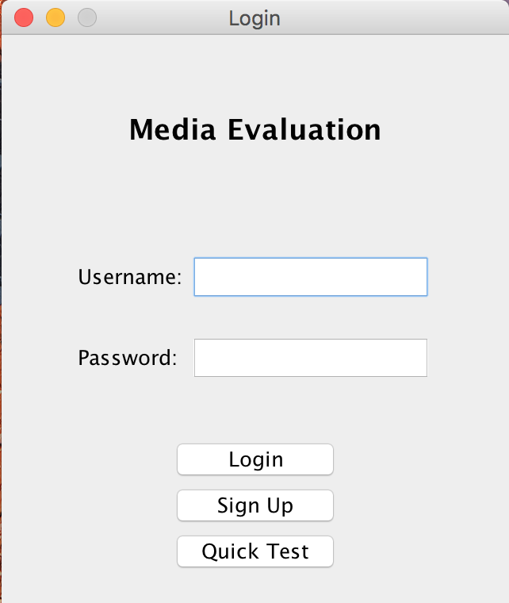

**(Figure 1)**

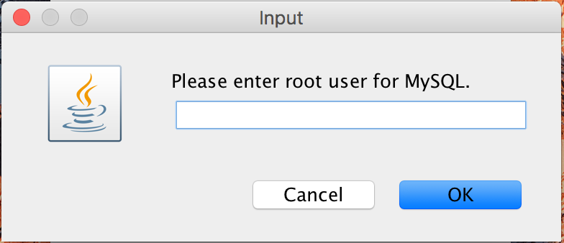

**(Figure 2)**

**Sign-up Screen** (Figure 3):

* Specify a new username and password.
* If program is running for the first time an input dialog (Figure 2) will pop up and ask for database credential in order the gain access to the database.

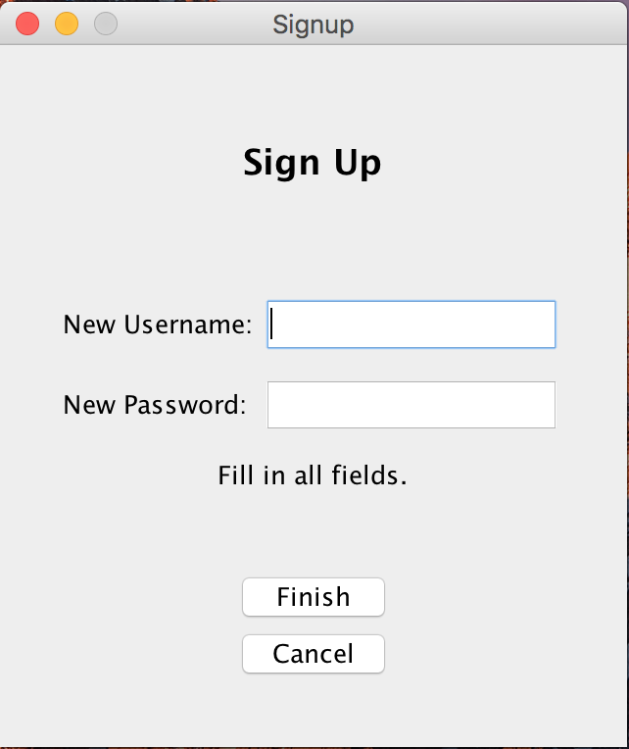

**(Figure 3)**

**Media Evaluation** (Figure 4):

* Program accepts ISBN numbers as input and evaluates them via Amazon’s website. An inventory is maintained and total price of all books is calculated.

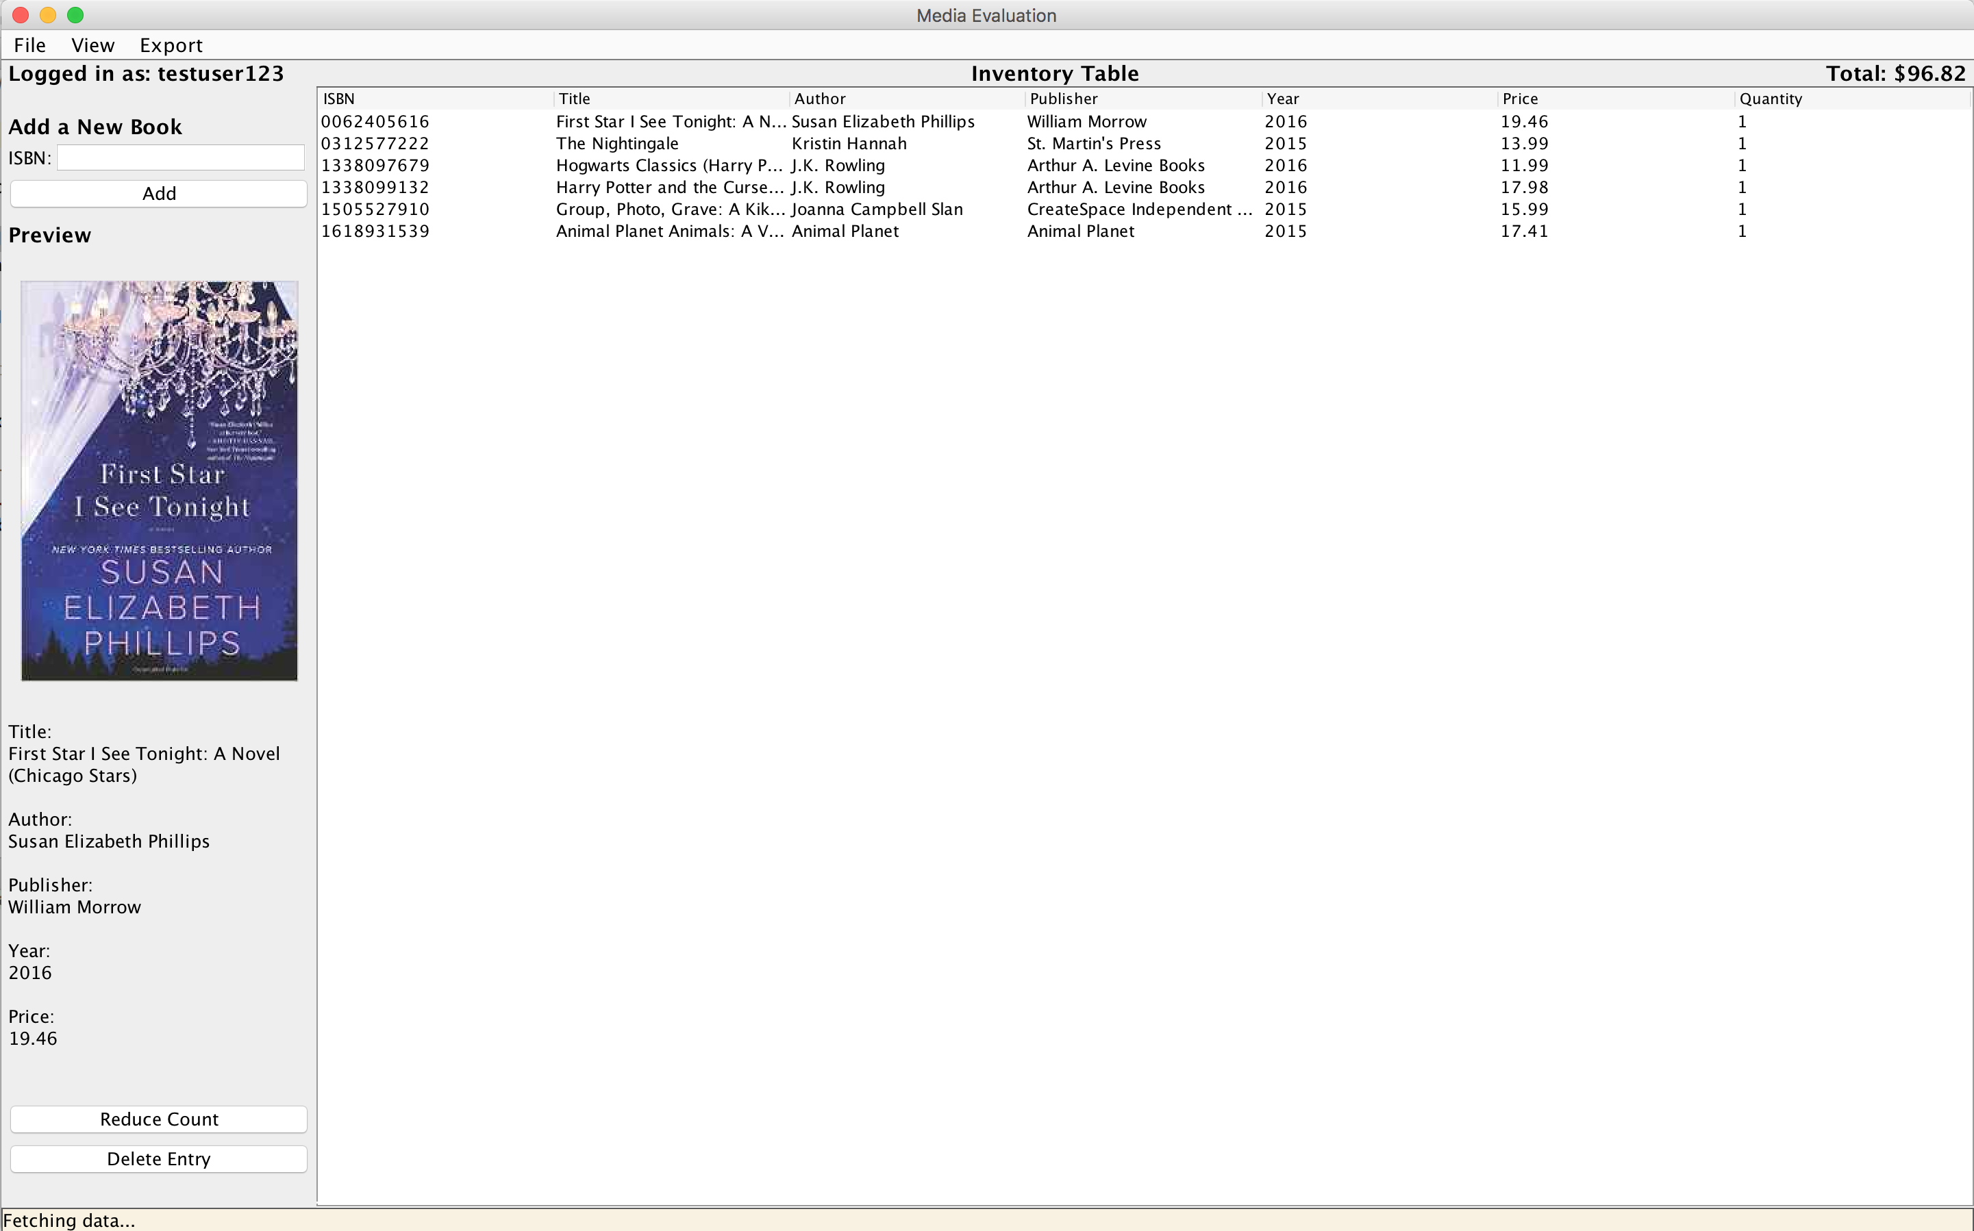

**(Figure 4)**

**Adding Books** (Figure 5):

* Enter an ISBN number and add a book using this interface

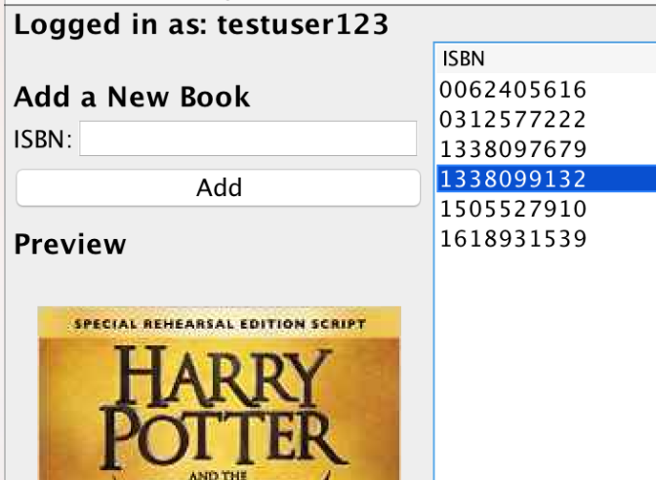

**(Figure 5)**

* Adding multiple books can be accomplished by preparing a text file with a list of ISBN numbers Followed by Clicking **File > Add...** to open and load the file. (Figure 6)
* Alternatively you may add entries upon initialization by providing an argument (ONE ARGUMENT ONLY) with an input file via command line
* If you wish you wish to overwrite your existing database with the entries of the file select **New Database...**

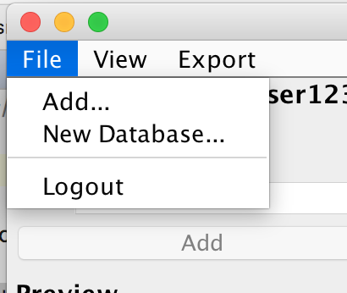

**(Figure 6)**

**Switching Tables** (Figure 7):

* Select **View** and choose the table you wish to view.
* **Inventory** displays all the books in your inventory with their corresponding information
* **History** displays all book entries ever inserted into the database

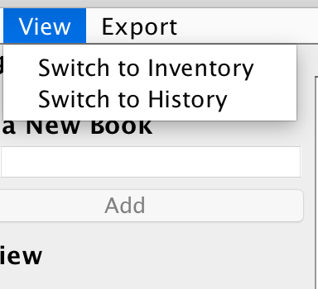

**(Figure 7)**

**Exporting Files** (Figure 8):

* Export a report file from any file containing a list of ISBN numbers. To do so click on, **Export > Report...** and select the file from which to generate a report on.
* Generating a file with the entire database can be accomplished by clicking **Export > Database...**

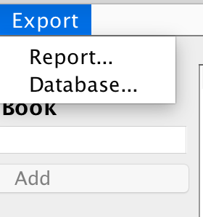

**(Figure 8)**

**Quick Reports**:

* Bypass the general system after logging in and generate a quick report based on an input file.
* For quick report specify **two** arguments in the command line.
* Argument 1: input(.txt)
* Argument 2: output(.txt)